Database Programming using Python (SQL)

MYSQL PROJECT

Saud Faisal Alharbi

First we opened the MAMP and do so configuration to open a local server for us and got to page called php myadmin

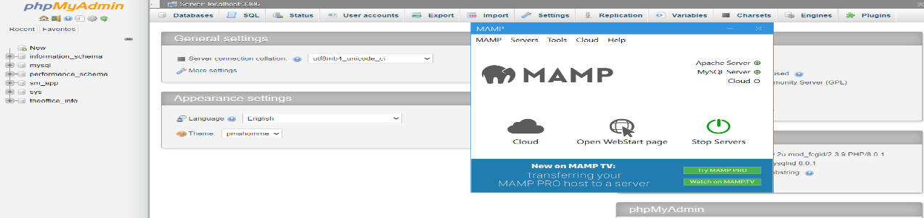To build our database there as you see here

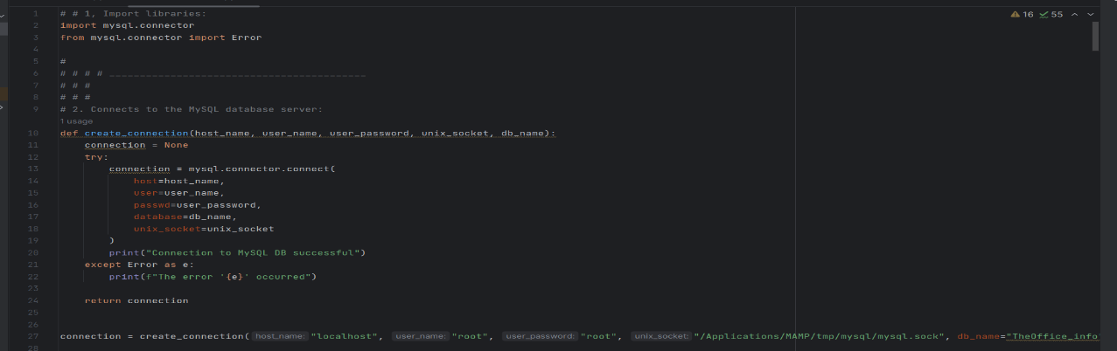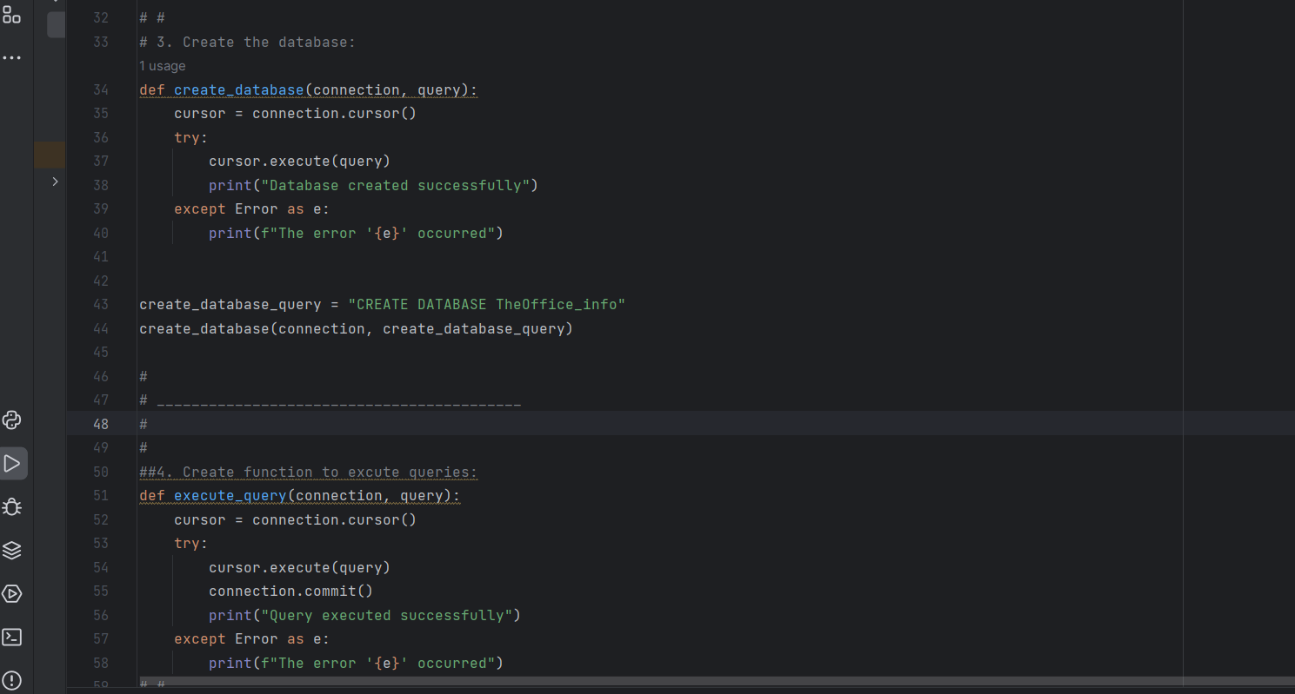Now we do some configuration in PyCharm to connect and create our database as you see here

Now we've created 6 tables and insert all the information to it and let all those information goes to our database in our

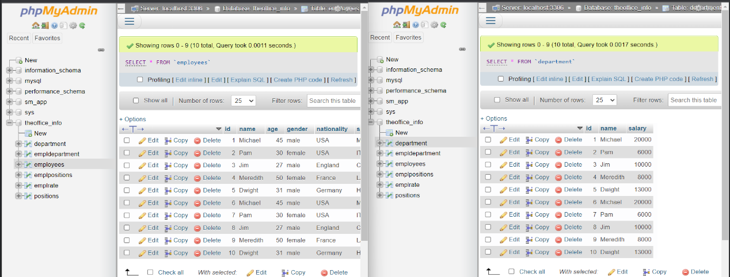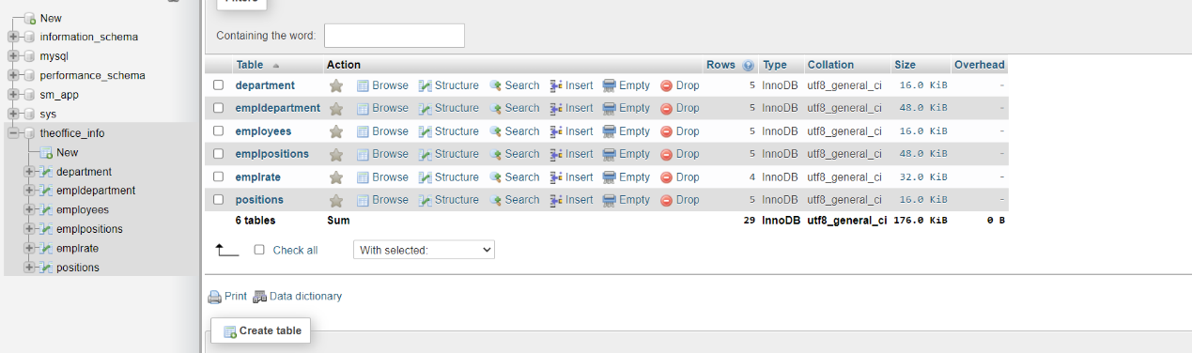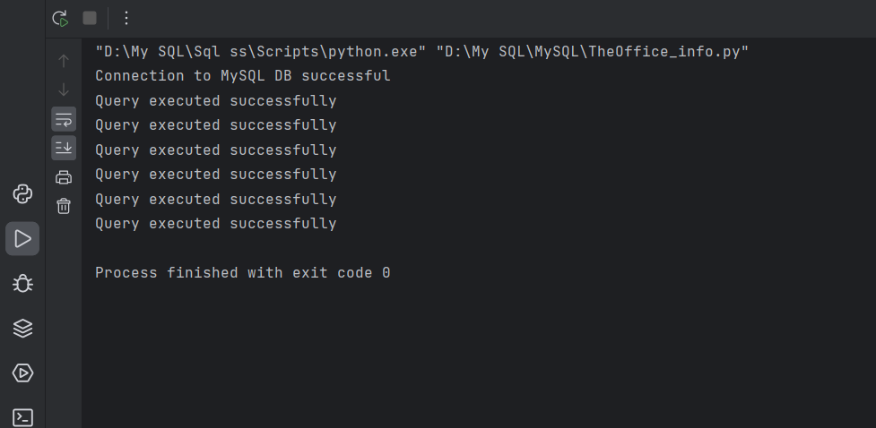 php my admin page as you see here

Now we'll do some Query and run them for example we'll use select clause in general and select with where clause and where clause in general and finally we'll used select with inner join as you see here

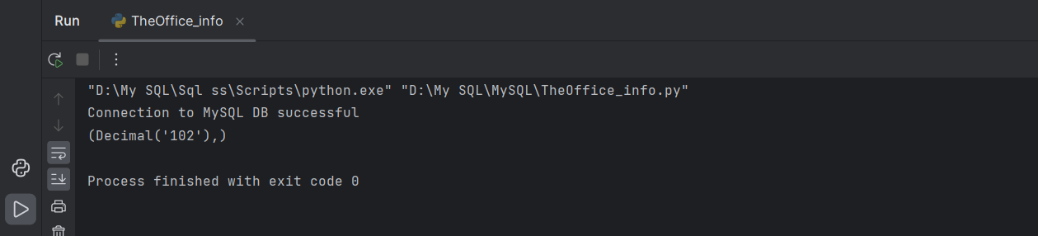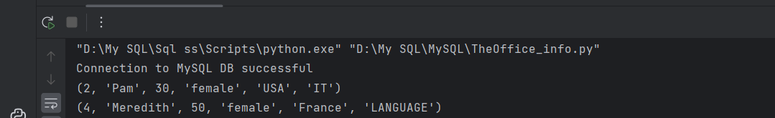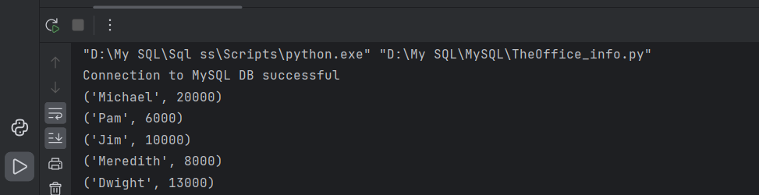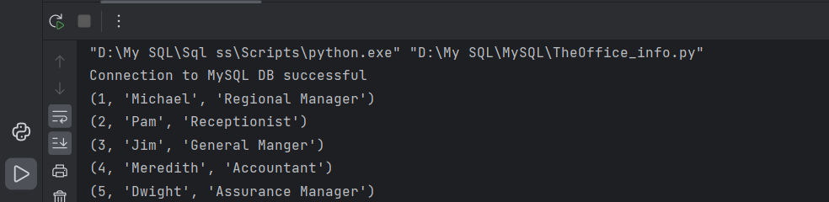

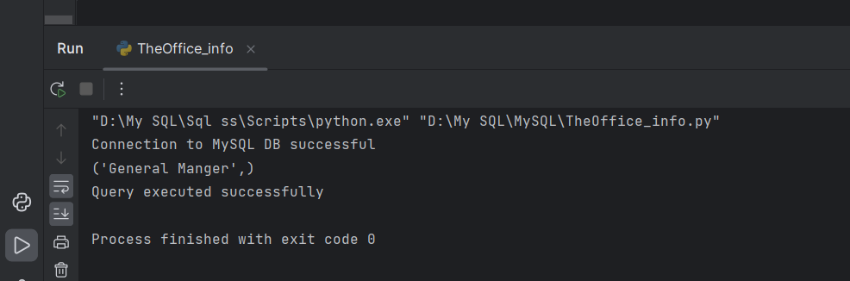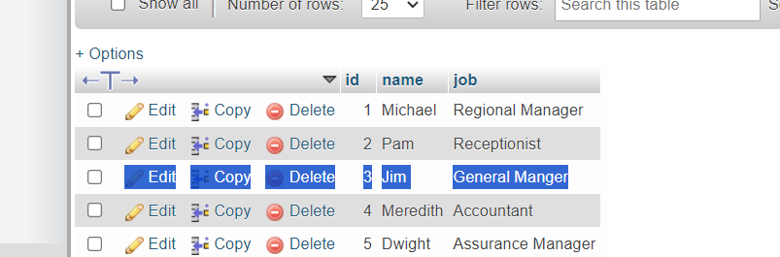Now we'll do Query for update and I'll show you how it updated in our database as you see here

Finally we'll use Delete to delete an employee with bad rate and I will show you how it's been deleted from our database as you see here

